Format for the Create Packet page:
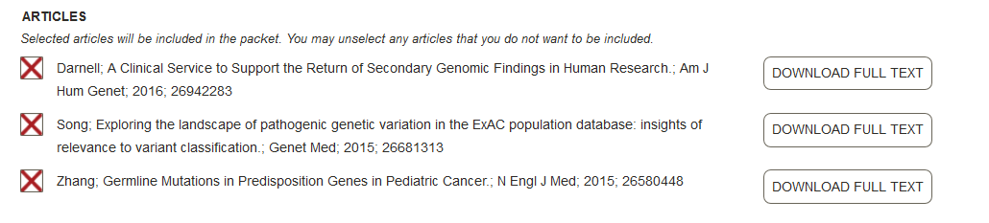
[RELATED CITATION: Smith NEJM 2015 PMID 12345678 (08736)]
BOARD MANAGER COMMENT: This seems to be an update of the Johnson paper on page 4.

Proposed format for the Board Member Packet page, Board Member article review page, and Board Manager Reviewed Packets page (Left column):

[No authors listed]
Melanoma research gathers momentum.
Lancet 385 (9985): 2323, 2015
PMID: 26088624
[RELATED CITATION: Smith NEJM 2015 PMID 12345678]

BOARD MANAGER COMMENT: Consider adding this with the Smith paper on page 74.
VIEW ABSTRACT | DOWNLOAD FULL TEXT

